**Some simple and basic docker network commands**

docker network ls

docker network create networkName

docker network inspect networkName

docker run --name containerName -d -it --net networkName imagename options

docker network connect networkName containerName

docker attach containerName

docker exec -it containerName options

docker network disconnect networkName containerName

docker network rm networkName

docker network prune

docker network –help

Forcefully remove containers:

Docker rm –f $(docker ps –aq)

Create custom network:

Docker network create --driver==bridge javahome

# Docker Networking Deep Dive

Docker networking is a fascinating topic. When one knows how to use Docker, then knowing it's networking and other internals helps even more.

In this document, I have explained:

* different networking modes available in docker,
* the mechanisms of service discovery,
* and procedure to join containers to each other for troubleshooting.

The following networks are available to you by default, when you install docker on your computer.

* Bridge - NAT - docker0
* Host - Uses host network
* None - Isolated / no networking

Other Docker networks available to you are the following, but are not covered in this document.

* Overlay - Swarm mode
* Macvlan - Legacy applications needing direct connection to physical network
* 3rd party network plugins

Note: In case you are wondering, in very simple terms, a software bridge is just another name for a (software) network switch!

## docker0 - The default "Bridge" network

dockerhost ~]$ docker network ls

NETWORK ID NAME DRIVER SCOPE

ab382bcb8342 bridge bridge local

c46f23496264 host host local

2c77e24c2352 none null local

Here is how the default bridge network looks like:

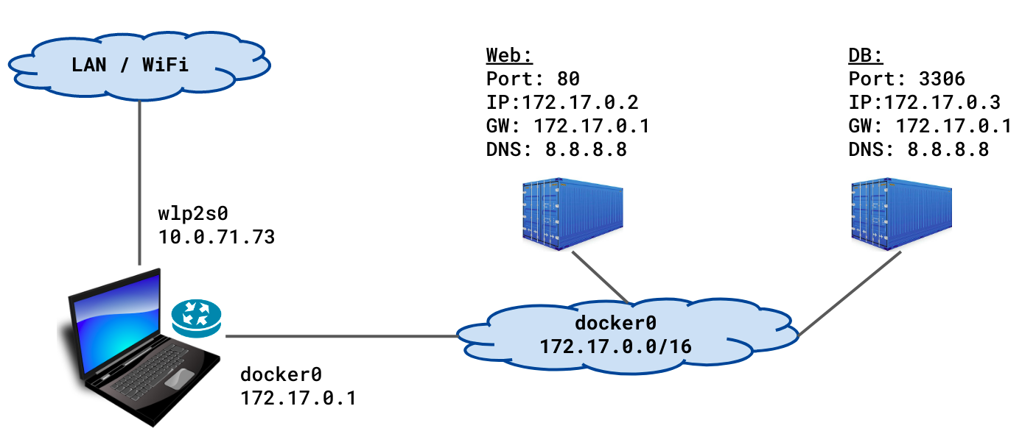

|  |
| --- |

Another way to look at the default bridge network:

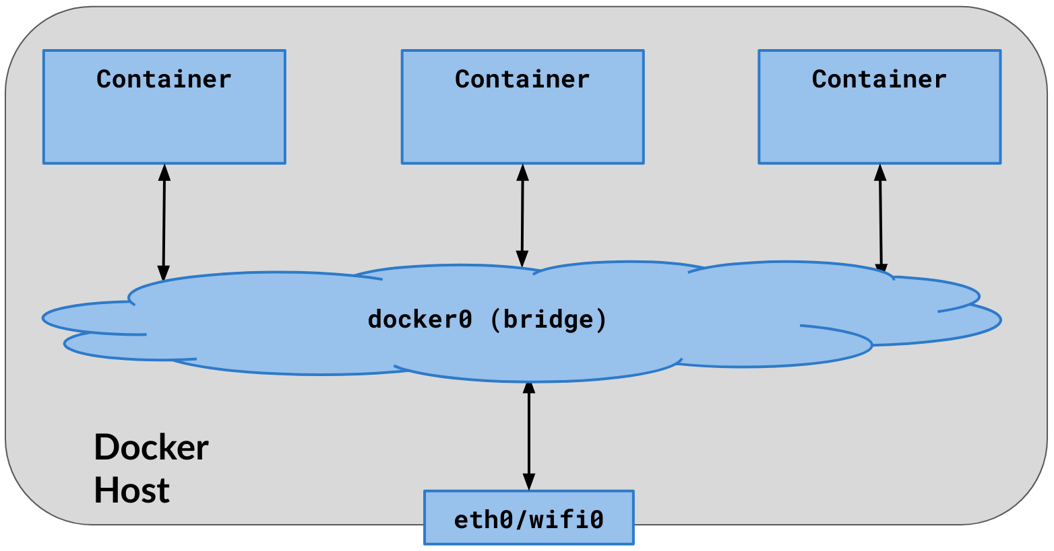

|  |
| --- |

Important points:

* By default, all containers are connected to the default bridge network, unless explicitly configured to connect to some other network.
* Containers talk to the docker host and outside world (ip_forward=1 and NAT)
* Docker host can talk to all containers using their IP addresses
* The (default) bridge network (interface) is visible/available on the host computer as docker0.
* At start up, Docker engine finds an unused network subnet on the docker host (normally 172.17.0.0/16), and assigns the first IP address of that network (normally 172.17.0.1) to the default bridge - docker0.
* There is no service discovery on default bridge.

Lets look at network interfaces on the host computer:

dockerhost ~]$ ip addr show

. . .

1: lo: <LOOPBACK,UP,LOWER_UP> mtu 65536 qdisc noqueue . . .

inet 127.0.0.1/8 scope host lo

. . .

2: wlp2s0: <BROADCAST,MULTICAST,UP,LOWER_UP> ... state UP . . .

inet 10.10.71.73/24 brd 10.10.71.255 scope global dynamic wlp2s0

. . .

9: docker0: <NO-CARRIER,BROADCAST,MULTICAST,UP> ... state DOWN . . .

inet 172.17.0.1/16 brd 172.17.255.255 scope global docker0

Note: state is DOWN when there are no running containers attached to this network interface/bridge.

Run two containers, which will automatically be connected to the default bridge:

dockerhost ~]$ docker run --name web \

-d praqma/network-multitool

dockerhost ~]$ docker run --name db \

-e MYSQL_ROOT_PASSWORD=secret \

-d mysql

dockerhost ~]$ docker ps

CONTAINER ID IMAGE COMMAND PORTS NAMES

8eaf8debb553 mysql "docker-entrypoint.s…" 3306 db

8c3f594512b1 praqma/network-multitool "nginx -g 'daemon of…" 80/tcp web

Inspect the bridge:

dockerhost ~]$ docker network inspect bridge

. . .

"Containers": {

"8c3f594512b1...": {

"Name": "web",

"EndpointID": "ca36034a9eb1...",

"MacAddress": "02:42:ac:11:00:02",

"IPv4Address": "172.17.0.2/16",

},

"8eaf8debb553...": {

"Name": "db",

"EndpointID": "3158ac7dee51...",

"MacAddress": "02:42:ac:11:00:03",

"IPv4Address": "172.17.0.3/16",

}

. . .

"com.docker.network.bridge.name": "docker0",

### The veth interfaces on bridge networks:

When containers are run and connected to bridge networks, a pair of network sockets is created. One is assigned to the container as eth0, and the other is assigned/connected to the bridge as vethX, where X is a random string.

dockerhost $ ip addr show

. . .

9: docker0: <... UP,LOWER_UP> ... state UP

link/ether 02:42:37:9e:00:f6 brd ff:ff:ff:ff:ff:ff

inet 172.17.0.1/16 brd 172.17.255.255 scope global docker0

. . .

11: veth229dc64@if10: <... UP,LOWER_UP> . . . master docker0 state UP

link/ether 2e:a8:cc:3b:78:09 brd ff:ff:ff:ff:ff:ff link-netnsid 0

. . .

13: veth18066aa@if12: <... UP,LOWER_UP> . . . master docker0 state UP

link/ether 52:83:73:27:cf:e3 brd ff:ff:ff:ff:ff:ff link-netnsid 1

. . .

|  |
| --- |

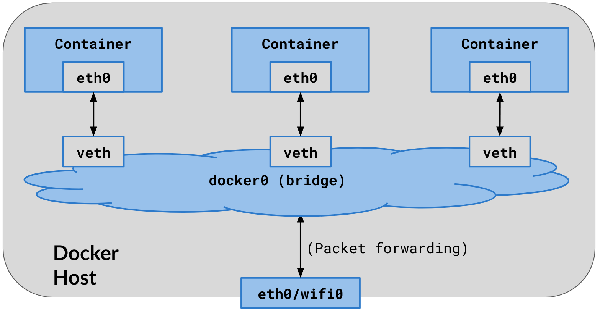

|  |
| --- |

### 

### Inspect containers connected to the bridge network:

dockerhost$ docker inspect web | egrep "MacAddress|IPAddress"

"IPAddress": "172.17.0.2",

"MacAddress": "02:42:ac:11:00:02",

dockerhost$ docker inspect db | egrep "MacAddress|IPAddress"

"IPAddress": "172.17.0.3",

"MacAddress": "02:42:ac:11:00:03",

dockerhost$ docker exec web ip addr show

. . .

10: eth0@if11: <...UP,LOWER_UP> . . . state UP . . .

link/ether 02:42:ac:11:00:02 brd ff:ff:ff:ff:ff:ff link-netnsid 0

inet 172.17.0.2/16 brd 172.17.255.255 scope global eth0

Notice that the IP and MAC of the web container as shown in the docker inspect command is same as found in the output of the docker exec command.

### Communication on the default docker0 bridge:

* The container inherits the DNS setting of the docker daemon (from the host), including the /etc/hosts and /etc/resolv.conf
* There is no service discovery on the default bridge
* Since there is no service discovery, containers must know IP of each other to be able to talk to each other, unless you use ‘--link’ ; that is not scalable beyond 2-3 containers, and is deprecated
* Trying to find IP address of the other containers is complicated
* All ports of a container are exposed to all other containers on the same bridge network. No ports are published on the host by default
* Publishing container ports to the host involves keeping track of which container publishes which port on the host.

Communication on default docker0 bridge in action:

dockerhost ~]$ docker exec -it web /bin/sh

/ # ping db

ping: db: Name does not resolve

/ # ping 172.17.0.3

PING 172.17.0.3 (172.17.0.3) 56(84) bytes of data.

64 bytes from 172.17.0.3: icmp_seq=1 ttl=64 time=0.154 ms

# telnet 172.17.0.3 3306

J

8.0.1Z 7lQ. �L]VP7}Q:T,caching_sha2_password

^]

/ #

## "User-defined" bridge network:

Users can create their own docker network. It has certain advantages, most importantly service discovery.

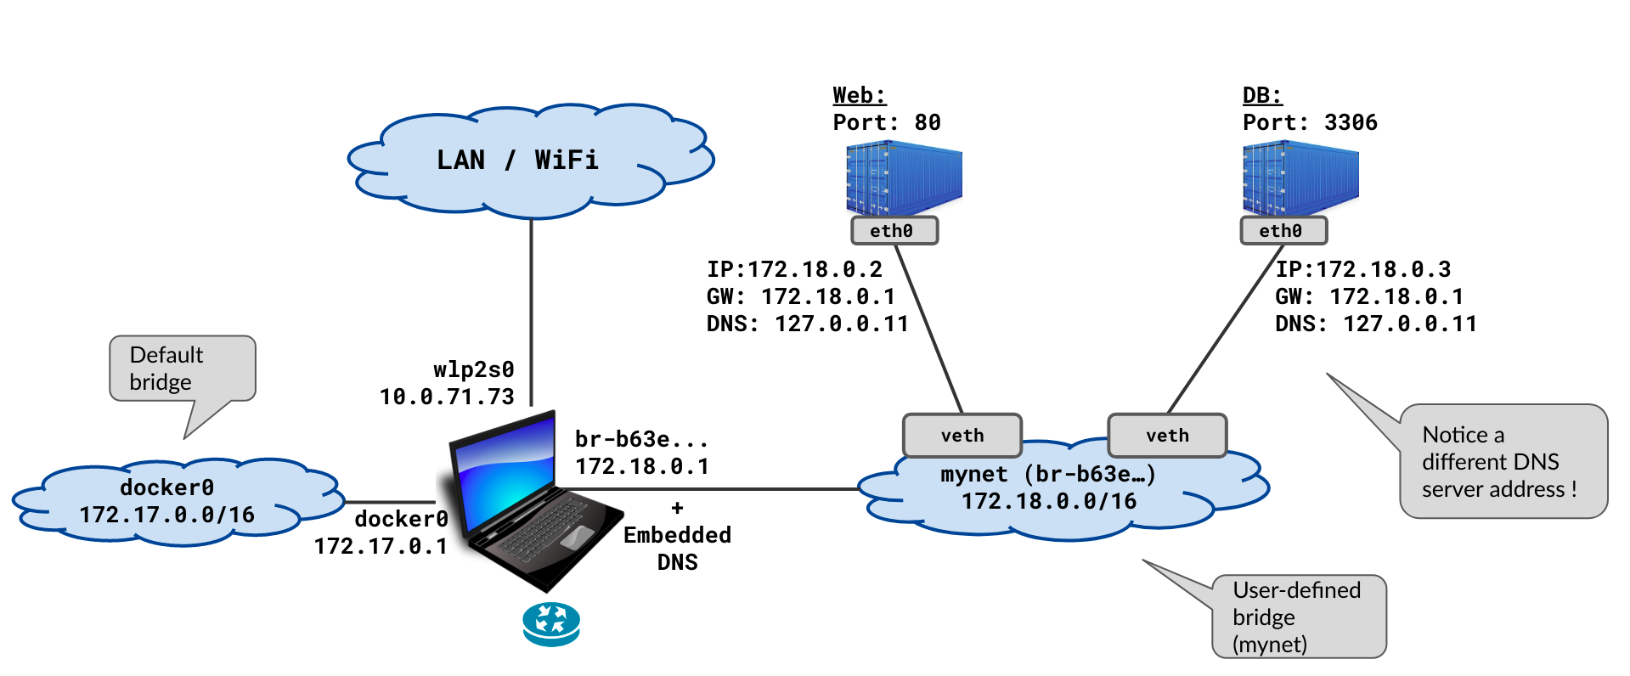

|  |
| --- |

Create a bridge network:

dockerhost ~]$ docker network create mynet

dockerhost ~]$ docker network ls

NETWORK ID NAME DRIVER SCOPE

c0a96220208b bridge bridge local

c46f23496264 host host local

b63ec54532ae mynet bridge local

2c77e24c2352 none null local

dockerhost ~]$ docker network inspect mynet

. . .

"Subnet": "172.18.0.0/16",

"Gateway": "172.18.0.1"

. . .

It should show up as a network interface on the host with the name br-<random-string> .

dockerhost ~]$ ip addr show

. . .

9: docker0: <...MULTICAST,UP> ... state DOWN ...

link/ether 02:42:37:9e:00:f6 brd ff:ff:ff:ff:ff:ff

inet 172.17.0.1/16 brd 172.17.255.255 scope global ...

. . .

14: br-b63ec54532ae: <...MULTICAST,UP> ... state DOWN ...

link/ether 02:42:ae:c2:65:74 brd ff:ff:ff:ff:ff:ff

inet 172.18.0.1/16 brd 172.18.255.255 scope global ...

. . .

Notice the ID of the "mynet" bridge is "br-b63e...".

Now run two containers and connect them on this network you created just now:

dockerhost ~]$ docker run --name=web --network=mynet \

-d praqma/network-multitool

dockerhost ~]$ docker run --name=db --network=mynet \

-e MYSQL_ROOT_PASSWORD=secret \

-d mysql

$ docker ps

CONTAINER ID IMAGE COMMAND PORTS NAMES

34f8f56fe8b2 mysql "docker-entrypoint.s…" 3306/tcp db

1d480f66ce00 praqma/network-multitool "nginx -g 'daemon of…" 80/tcp web

Inspect the network:

dockerhost ~]$ docker network inspect mynet

. . .

"Name": "mynet",

"Subnet": "172.18.0.0/16",

"Gateway": "172.18.0.1"

. . .

"Name": "web",

"MacAddress": "02:42:ac:12:00:02",

"IPv4Address": "172.18.0.2/16",

. . .

"Name": "db",

"MacAddress": "02:42:ac:12:00:03",

"IPv4Address": "172.18.0.3/16",

Notice that the containers connected to the mynet show up in the output when the network "mynet" is inspected.

### Service Discovery on user-defined bridge:

There is (DNS based) service discovery on user-defined bridge. How it works? and how it looks like? - is explained next.

exec into a container connected to the network you created just now. Notice that it can resolve the names of the other containers on the same network.

dockerhost ~]$ docker exec -it web /bin/sh

/ # ping -c 1 db

PING db (172.18.0.3) 56(84) bytes of data.

64 bytes from db.mynet (172.18.0.3): icmp_seq=1 ttl=64 time=0.084 ms

/ # ping -c 1 yahoo.com

PING yahoo.com (72.30.35.10) 56(84) bytes of data.

64 bytes from media-router-fp2.prod1.media.vip.bf1.yahoo.com (72.30.35.10): icmp_seq=1 ttl=52 time=165 ms

/ # dig +short yahoo.com

98.137.246.8

72.30.35.10

. . .

Above works, because there is an embedded DNS in the docker service on the host computer. It is explained below.

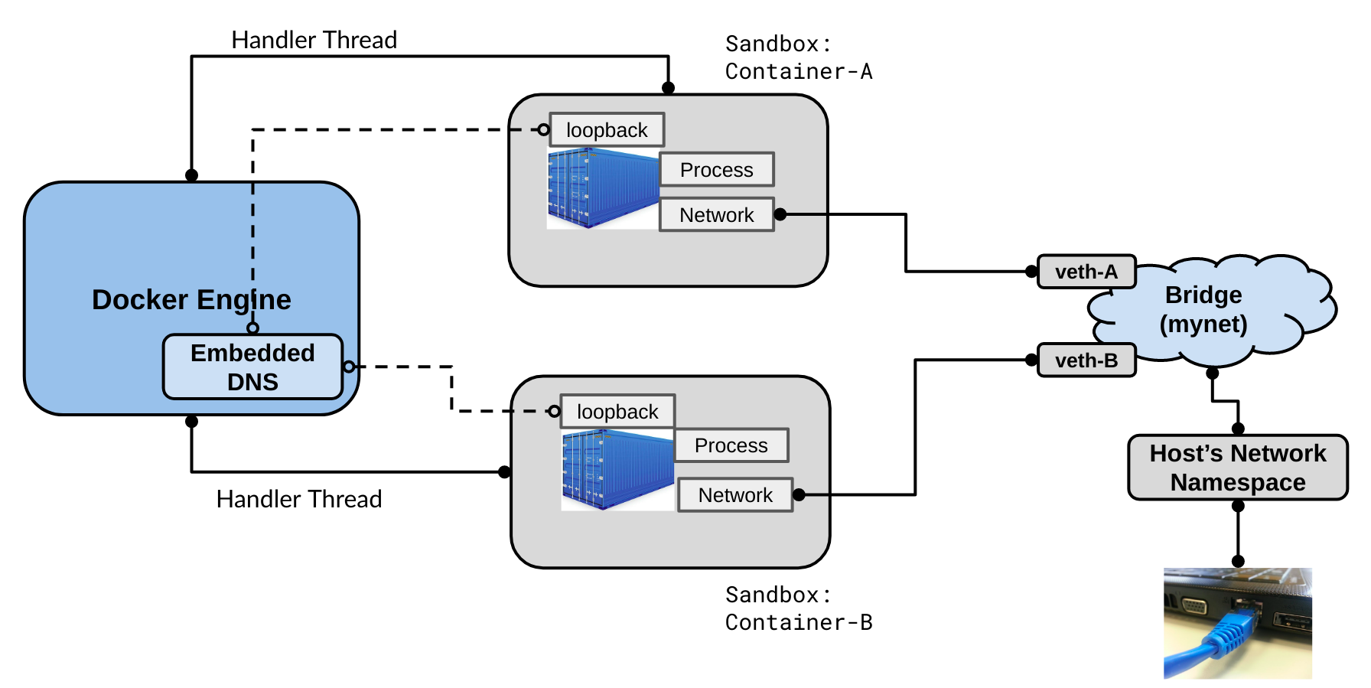

|  |
| --- |

exec into a container connected to mynet, and do some investigation.

dockerhost ~]$ docker exec web cat /etc/resolv.conf

search home.wbitt.com

nameserver 127.0.0.11

options ndots:0

dockerhost ~]$ docker exec db cat /etc/resolv.conf

search home.wbitt.com

nameserver 127.0.0.11

options ndots:0

dockerhost ~]$ docker exec web netstat -antup

Active Internet connections (servers and established)

Proto Recv-Q Send-Q Local Address Foreign Address State PID/Program

tcp 0 0 127.0.0.11:40521 0.0.0.0:* LISTEN -

tcp 0 0 0.0.0.0:80 0.0.0.0:* LISTEN 1/nginx

udp 0 0 127.0.0.11:38657 0.0.0.0:* -

The /etc/resolv.conf says that the DNS is available at 127.0.0.11, and on port 53, which is implied. But, the netstat output does not show any process listening on port 53, neither on TCP, nor UDP. So where is the DNS server?

Let’s add a tools container to "mynet", to look under the hood. We need some extra CAP-abilities for our container being used for investigation.

$dockerhost ~] docker run \

--name multitool \

--network mynet \

--cap-add=NET_ADMIN \

--cap-add=NET_RAW \

-it praqma/network-multitool /bin/bash

bash-5.0# ping -c 1 db

PING db (172.18.0.3) 56(84) bytes of data.

64 bytes from db.mynet (172.18.0.3): icmp_seq=1 ttl=64 time=0.074 ms

bash-5.0# dig db

;; QUESTION SECTION:

;db. IN A

;; ANSWER SECTION:

db. 600 IN A 172.18.0.3

;; SERVER: 127.0.0.11#53(127.0.0.11)

Notice the DNS server responding to our DNS queries is: 127.0.0.11#53 , but we don't see a process running on port 53 in this container! So what is going on here?

Check netstat output on this tools container:

bash-5.0# netstat -ntlup

Active Internet connections (only servers)

Proto Recv-Q Send-Q Local Address Foreign Address State PID/Program

tcp 0 0 127.0.0.11:37553 0.0.0.0:* LISTEN -

udp 0 0 127.0.0.11:35464 0.0.0.0:* -

Observations:

* The ports 37553 and 35464 do not look like DNS server ports! So what are these?
* Why these processes inside the container do not have PIDs?

Answer to all DNS mystery - IPTables magic!

Check the iptables rules in the tools container:

bash-5.0# iptables-save

*nat

:PREROUTING ACCEPT [18:2796]

:INPUT ACCEPT [0:0]

:OUTPUT ACCEPT [4:171]

:POSTROUTING ACCEPT [9:502]

:DOCKER_OUTPUT - [0:0]

:DOCKER_POSTROUTING - [0:0]

-A OUTPUT -d 127.0.0.11/32 -j DOCKER_OUTPUT

-A POSTROUTING -d 127.0.0.11/32 -j DOCKER_POSTROUTING

# Queries for DNS:

-A DOCKER_OUTPUT -d 127.0.0.11/32 -p tcp -m tcp --dport 53 -j DNAT --to-destination 127.0.0.11:37553

-A DOCKER_OUTPUT -d 127.0.0.11/32 -p udp -m udp --dport 53 -j DNAT --to-destination 127.0.0.11:35464

# Response from DNS:

-A DOCKER_POSTROUTING -s 127.0.0.11/32 -p tcp -m tcp --sport 37553 -j SNAT --to-source :53

-A DOCKER_POSTROUTING -s 127.0.0.11/32 -p udp -m udp --sport 35464 -j SNAT --to-source :53

Explanation: From the iptables rules, we learn that any (DNS query) traffic looking for 127.0.0.11:53 is actually redirected to 127.0.0.11:37553 (for TCP), and to 127.0.0.11:35464 (for UDP).

There is a docker process running on these ports inside the container, which are actually docker's embedded DNS's hooks. When anything is sent on these hooks, docker's embedded DNS responds with the results of the query.

The last two iptables rules show that when the results/return DNS traffic is received from these two special ports (or processes), they are changed back (SNAT - Source Network Address Translation) to the same IP address but with port 53 as source port. For the innocent dig or nslookup commands, the query went to 127.0.0.11:53 and results came back from the same. This is the story! Below is the diagram, which should help make sense of all of this explanation.

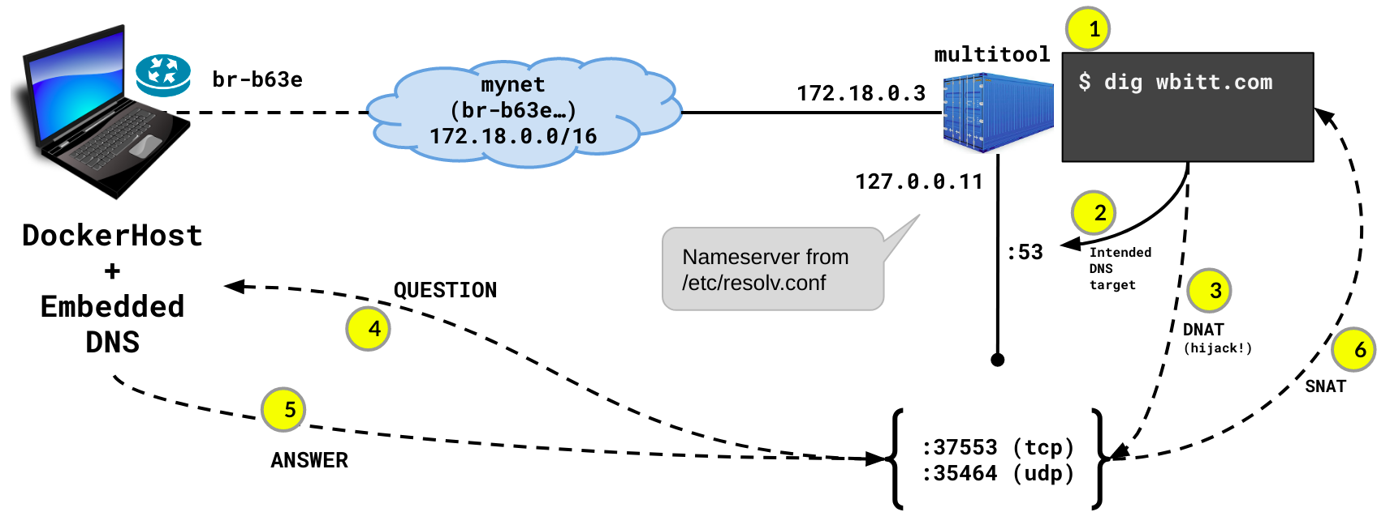

|  |
| --- |

Notes:

* Above (iptables command) won't work without adding certain CAP-abilities to the container at run time. That is why we used the extra CAP-abilities: --cap-add=NET_ADMIN and --cap-add=NET_RAW
* By default, DNS uses UDP for queries less than 512 bytes. It switches to TCP for queries larger than 512 bytes. UDP is faster, simpler and lighter.

## "Compose-defined" bridge network:

This is exactly the same as user-defined bridge, except docker-compose creates it automatically, when you bring up a docker-compose based application stack.

Here is a simple docker-compose application stack:

simpleweb]$ cat docker-compose.yml

version: "3"

services:

apache:

image: httpd:alpine

postgres:

image: postgres

environment:

- POSTGRES_PASSWORD=secret

Bring up the compose stack and investigate it's networking.

simpleweb]$ docker-compose up -d

Creating network "simpleweb_default"

Creating simpleweb_apache_1 ... done

Creating simpleweb_postgres_1 ... done

simpleweb]$ docker network ls

NETWORK ID NAME

c0a96220208b bridge bridge

c46f23496264 host host

b63ec54532ae mynet bridge

2c77e24c2352 none null

245ef6384978 simpleweb_default bridge

simpleweb]$ docker-compose ps

Name Command State Ports

-----------------------------------------------------------------------

simpleweb_apache_1 httpd-foreground Up 80/tcp

simpleweb_postgres_1 docker-entrypoint.sh postgres Up 5432/tcp

dockerhost ~]$ ip addr show

. . .

29: br-245ef6384978: <... UP,LOWER_UP> ... state UP ...

link/ether 02:42:bf:f0:d6:04 brd ff:ff:ff:ff:ff:ff

inet 172.19.0.1/16 brd 172.19.255.255 scope global br-245ef6384978

31: vethd85cd5e@if30: <... UP,LOWER_UP> ... master br-245ef6384978 state UP ..

link/ether 72:7c:3e:bf:8a:b6 brd ff:ff:ff:ff:ff:ff link-netnsid 2

33: veth2ed0387@if32: <... UP,LOWER_UP> ... master br-245ef6384978 state UP

link/ether 62:6f:4c:77:19:4f brd ff:ff:ff:ff:ff:ff link-netnsid 3

Notice the new bridge is created for the compose application, and two veth interfaces show up for the two containers connected on that bridge.

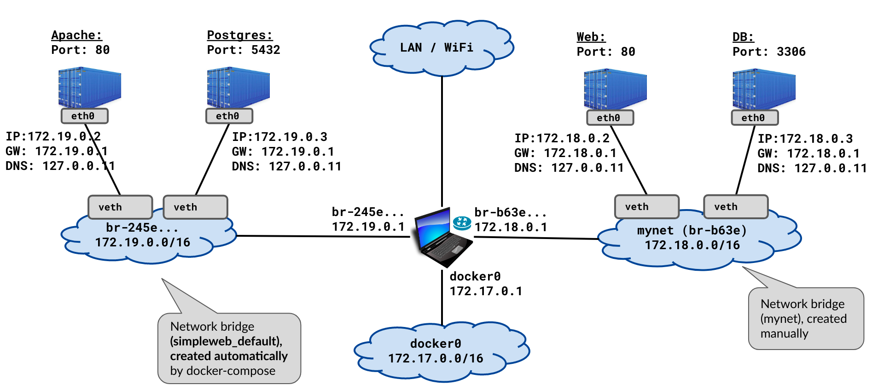

|  |
| --- |

## Other aspects of bridge networks:

### No service discovery and no communication b/w "different" bridge networks:

In case there are multiple docker networks on the same computer, containers from one network do not know about containers on the other network, nor can they talk to them. This is a good thing to have for security reasons.

Here is how it is investigated:

dockerhost ~]$ docker exec -it simpleweb_apache_1 /bin/sh

/usr/local/apache2 # ping postgres

PING postgres (172.19.0.3): 56 data bytes

64 bytes from 172.19.0.3: seq=0 ttl=64 time=0.188 ms

/usr/local/apache2 # ping db

ping: bad address 'db'

/usr/local/apache2 # ping 172.18.0.2

PING 172.18.0.2 (172.18.0.2): 56 data bytes

2 packets transmitted, 0 packets received, 100% packet loss

/usr/local/apache2 # ping 172.18.0.1

PING 172.18.0.1 (172.18.0.1): 56 data bytes

64 bytes from 172.18.0.1: seq=0 ttl=64 time=0.105 ms

Notice, containers of one bridge network are not able to resolve names of containers on the other docker networks, and unable to talk to containers on other docker networks - which is Good!

Same applies for the containers on the other network:

dockerhost]$ docker exec -it web /bin/sh

/ # ping db

PING db (172.18.0.3) 56(84) bytes of data.

64 bytes from db.mynet (172.18.0.3): icmp_seq=1 ttl=64 time=0.085 ms

/ # ping postgres

ping: postgres: Name does not resolve

/ # ping 172.19.0.3

PING 172.19.0.3 (172.19.0.3) 56(84) bytes of data.

1 packets transmitted, 0 received, 100% packet loss, time 0ms

/ # ping 172.19.0.1

PING 172.19.0.1 (172.19.0.1) 56(84) bytes of data.

64 bytes from 172.19.0.1: icmp_seq=1 ttl=64 time=0.081 ms

### Accessibility from host computer:

All containers on any docker (bridge) network, are accessible from the host on the network layer. Below, we can see that our host computer can access containers from two different bridge networks.

dockerhost]$ ping 172.18.0.2

PING 172.18.0.2 (172.18.0.2) 56(84) bytes of data.

64 bytes from 172.18.0.2: icmp_seq=1 ttl=64 time=0.060 ms

dockerhost]$ ping 172.19.0.3

PING 172.19.0.3 (172.19.0.3) 56(84) bytes of data.

64 bytes from 172.19.0.3: icmp_seq=1 ttl=64 time=0.142 ms

dockerhost]$ curl 172.18.0.2

<title>Welcome to nginx!</title>

dockerhost]$ curl 172.19.0.2

<html><body><h1>It works!</h1></body></html>

## The Docker "Host" network:

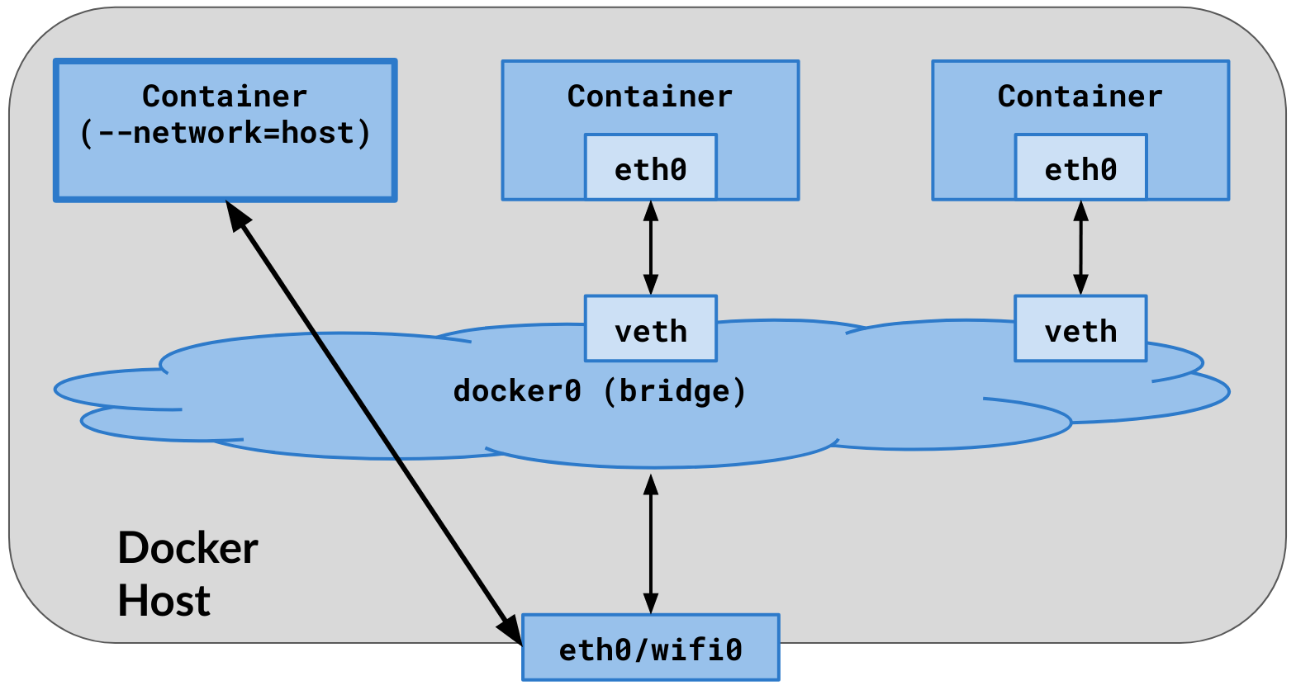

|  |
| --- |

* The container shares the host’s networking namespace
* Container’s network stack is not isolated from the Docker host
* No veth pairs are created on host. All network interfaces of the host are visible inside the container.
* All routing of host computer is visible inside the container.
* No IP address is allocated to the container, it shares it with the host.
* Port-mapping does not take effect. “-p”, and “-P” options are ignored. Whatever the port of the application inside the container, it is available as-is on the host’s IP address.
* Useful to optimize performance, as it does not require NAT between host and container. No “userland-proxy” is created for each port of the container.
* Host networking only works on Linux hosts

Here is how containers on the host network look like:

dockerhost ~]$ docker run --name multitool --network host \

-d praqma/network-multitool

dockerhost ~]$ docker ps

CONTAINER ID IMAGE COMMAND CREATED STATUS PORTS NAMES

dc61439f5546 praqma/network-multitool "nginx ..." 1 minute ago Up 37 seconds multitool

dockerhost ~]$ docker exec -it multitool /bin/sh

/ # ip addr show

1: lo: <LOOPBACK,UP,LOWER_UP> mtu 65536 state UNKNOWN group default qlen 1000

link/loopback 00:00:00:00:00:00 brd 00:00:00:00:00:00

inet 127.0.0.1/8 scope host lo

valid_lft forever preferred_lft forever

2: wlp2s0: <BROADCAST,MULTICAST,UP,LOWER_UP> mtu 1500 state UP group default qlen 1000

link/ether 34:f3:9a:27:e7:2d brd ff:ff:ff:ff:ff:ff

inet 192.168.0.14/24 brd 192.168.0.255 scope global dynamic noprefixroute wlp2s0

9: docker0: <NO-CARRIER,BROADCAST,MULTICAST,UP> mtu 1500 state DOWN group default

link/ether 02:42:d4:fa:e4:ea brd ff:ff:ff:ff:ff:ff

inet 172.17.0.1/16 brd 172.17.255.255 scope global docker0

Inspect the container, and investigate it's networking.

dockerhost ~]$ docker container inspect nginx

. . .

"Pid": 2905,

. . .

"Name": "/nginx",

. . .

"NetworkMode": "host",

. . .

"ExposedPorts": {

"80/tcp": {}

. . .

"Networks": {

"host": {

. . .

"IPAddress": "",

. . .

"MacAddress": "",

dockerhost ~]# netstat -ntlp

Active Internet connections (only servers)

Proto Recv-Q Send-Q Local Address Foreign Address State PID/Program

. . .

tcp 0 0 127.0.0.1:631 0.0.0.0:* LISTEN 1131/cupsd

tcp 0 0 0.0.0.0:80 0.0.0.0:* LISTEN 2905/nginx

tcp 0 0 0.0.0.0:443 0.0.0.0:* LISTEN 2905/nginx

dockerhost ~]$ curl localhost

Praqma Network MultiTool (with NGINX) - kworkhorse.home.wbitt.com -

Notes:

* The multitool container's entrypoint script is responsible to create the above web-page with container's IP in it. Since the container does not have any network interfaces of it’s own, the script did not find any IP address for it, and left the IP address empty in the generated web-page. That is why there is no IP address in the output of the curl command above!
* Since the container is using host’s network, it’s services are accessible directly on host computer, using localhost and on the network IP address of the host connected to LAN/wifi.

## The "None" network:

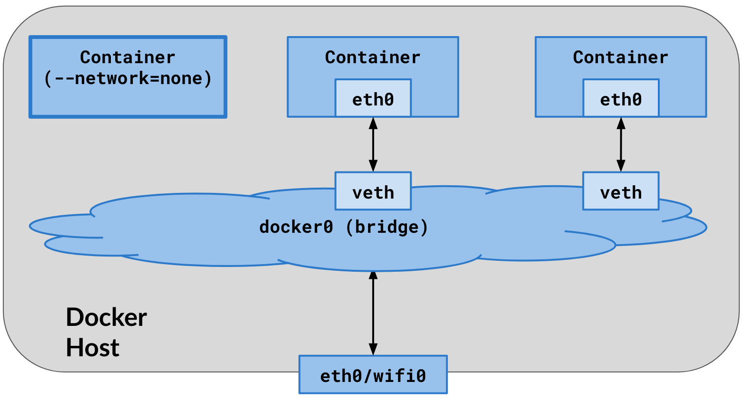

|  |
| --- |

* The container networking is completely disabled. No IP, No egress & no ingress traffic.
* Only loopback device is available
* No veth pairs are created on host.
* Port-mapping does not take effect. “-p”, and “-P” options are ignored.
* Used as a security sandbox, to test something in complete isolation.

Lets run a container by connecting it to the "none" network:

dockerhost ~]$ docker run --name multitool \

--network none \

-p 80:80 \

-d praqma/network-multitool

dockerhost ~]$ docker ps

CONTAINER ID IMAGE COMMAND CREATED STATUS PORTS NAMES

6f0637d31ebe nginx “nginx …” 2 min ago Up 2 min multitool

dockerhost ~]$ docker exec -it multitool /bin/bash

bash-5.0# ifconfig -a

lo Link encap:Local Loopback

inet addr:127.0.0.1 Mask:255.0.0.0

UP LOOPBACK RUNNING MTU:65536 Metric:1

bash-5.0# route -n

Kernel IP routing table

Destination Gateway Genmask Flags Metric Ref Use Iface

bash-5.0#

Notice that passing -p 80:80 has no effect. Also notice there are no network interfaces in the container, and no routing table.

# Join one container to another container

Most of the times, the containers are very limited in terms of how much software/tools are inside them. This is done to keep their size small, and also for security reasons. However, troubleshooting them becomes very difficult, as they don't have enough tools in them. There is a possibility to join a tools container to a main container.

Examples of such limited containers are: nginx, mysql, etc, or images built from scratch. Examples of tools containers are: busybox, alpine, praqma/network-multitool , etc.

## Join one container to another container’s network namespace:

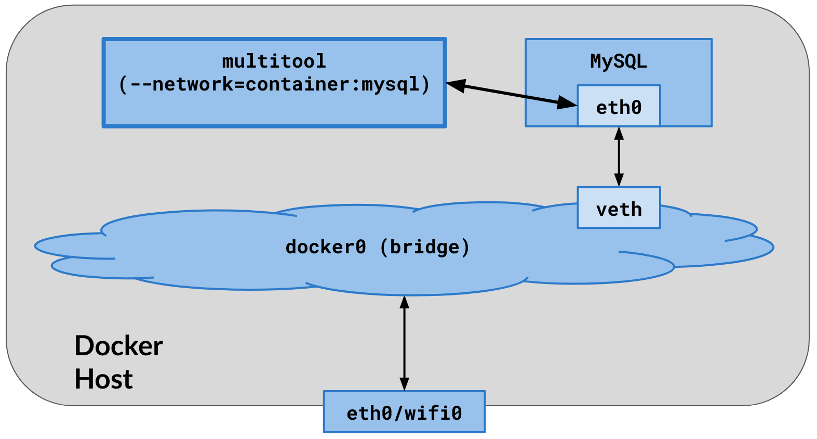

|  |
| --- |

* The container being joined does not have an IP of it’s own. It joins the IP/network namespace of the main container.
* No extra veth interfaces are created on the host for the joining container.
* The container being joined is not able to see the processes of the main container.

Lets run a typical mysql container, which does not have any troubleshooting tools inside it. Investigate the container, using network and process management tools:

dockerhost ~]$ docker run --name mysql -e

MYSQL_ROOT_PASSWORD=secret -d mysql

dockerhost ~]$ docker ps

CONTAINER ID IMAGE COMMAND CREATED STATUS PORTS NAMES

e53613c1ebe1 mysql "docker …" 1 min ago UP 1 min 3306/tcp mysql

dockerhost ~]$ docker exec -it mysql /bin/sh

# ifconfig

/bin/sh: 2: ifconfig: not found

# ping 8.8.8.8

/bin/sh: 3: ping: not found

# ps aux

/bin/sh: 4: ps: not found

Alright, lets attach a tools container to this container for troubleshooting:

dockerhost ~]$ docker run --name busybox \

--network container:mysql \

--rm -it busybox /bin/sh

/ # ip addr show

. . .

46: eth0@if47: <...UP,LOWER_UP> ... qdisc noqueue state UP

link/ether 02:42:ac:11:00:02 brd ff:ff:ff:ff:ff:ff link-netnsid 0

inet 172.17.0.2/16 brd 172.17.255.255 scope global eth0

/ # netstat -ntlp

Active Internet connections (only servers)

Proto Recv-Q Send-Q Local Address Foreign Address State PID/Program

tcp6 0 0 :::3306 :::* LISTEN -

/ # ping 8.8.8.8

64 bytes from 8.8.8.8: icmp_seq=1 ttl=54 time=17.4 ms

Investigate how do things look from Docker’s perspective:

dockerhost ~]$ docker ps

CONTAINER ID IMAGE COMMAND CREATED STATUS PORTS NAMES

e53613c1ebe1 mysql "docker …" 15 min ago UP 15 min 3306/tcp mysql

2acc045dc3cd busybox "/docker …" 12 min ago Up 12 min busybox

dockerhost ~]$ docker inspect mysql

. . .

"NetworkMode": "default",

. . .

"IPAddress": "172.17.0.2",

"MacAddress": "02:42:ac:11:00:02",

dockerhost ~]$ docker inspect busybox

. . .

"NetworkMode": "container:e53613c1ebe1",

. . .

"IPAddress": "",

"MacAddress": "",

Notice that the tools container does not have an IP address.

Now, when a container is joined to another contianer's network namespace, can we also see processes inside the other container? Unfortunately, not. Joining a container’s network does not help if we want to run process troubleshooting tools, such as ps, strace, gdb, etc, on the processes in the main container, because the processes from the main container are not visible to the tools container.

dockerhost ~]$ docker run --name busybox \

--network container:mysql \

--rm -it busybox /bin/sh

/ # ps aux

PID USER TIME COMMAND

1 root 0:00 /bin/sh

6 root 0:00 ps aux

/ #

Notice, we are inside the busybox container, and there is no mysql process visible.

## Join a container to process-namespace of another container

To be able to manage the processes of the main container, the tools container should be connected to the process namespace of the main container.

|  |
| --- |

To look at the processes of the main mysql container, make the busybox container join the process-namespace of the mysql container, using: --pid container:<MainContainerID>

dockerhost ~]$ docker run --name busybox \

--pid container:mysql \

--rm -it busybox /bin/sh

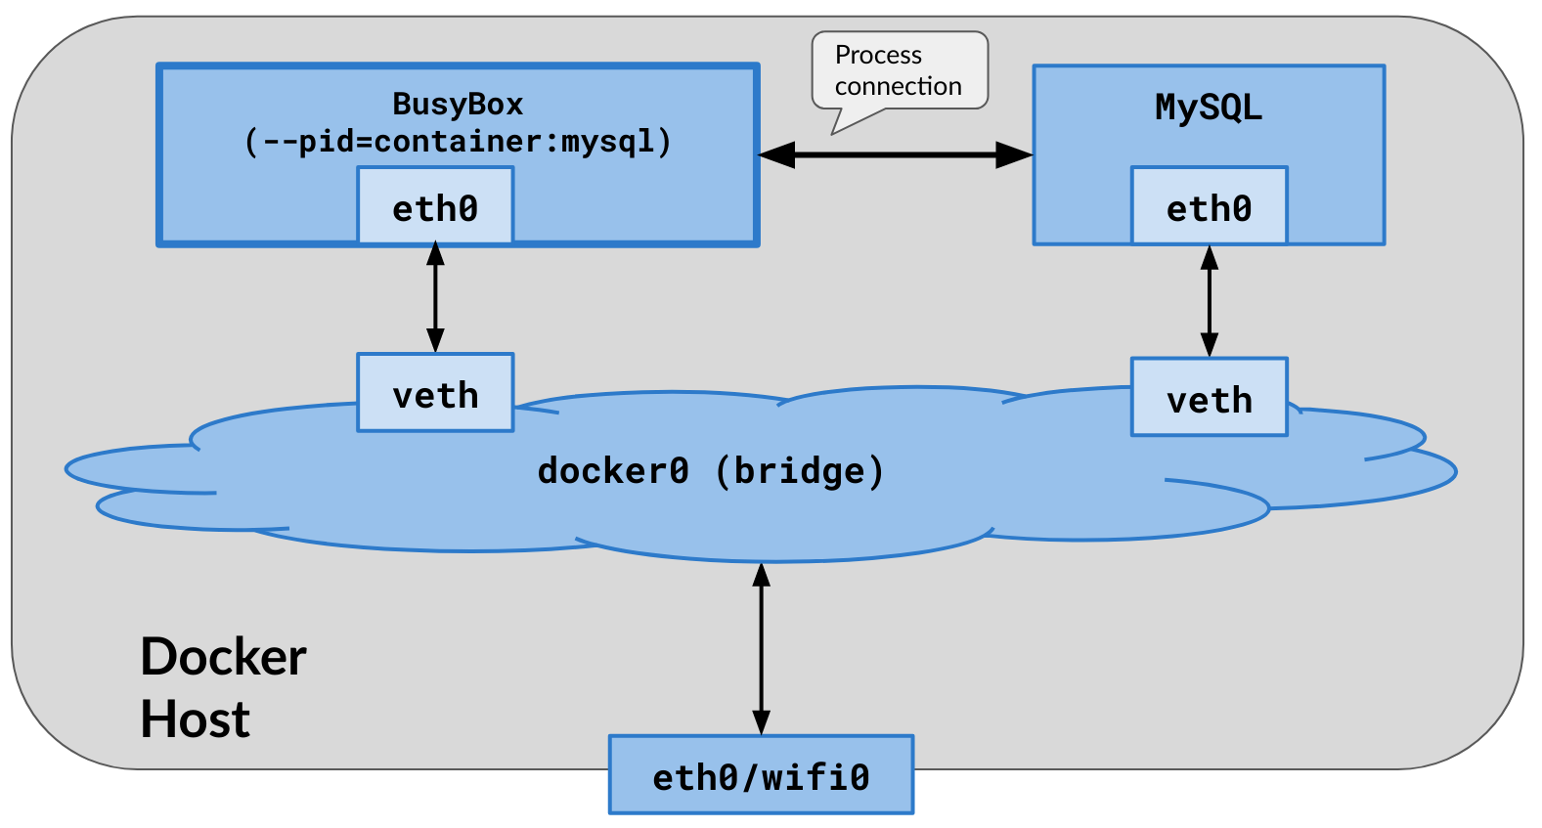

/ # ps aux

PID USER TIME COMMAND

1 999 0:25 mysqld

505 root 0:00 /bin/sh

510 root 0:00 ps aux

/ #

Notice that we are inside the busybox container, and now we see mysql process as well!

Remember, when run this way, the joining container gets its own network stack, different from the network stack of main container it is joined with. Here is how it looks like:

/ # ip addr show

1: lo: <LOOPBACK,UP,LOWER_UP> mtu 65536 qdisc noqueue qlen 1000

inet 127.0.0.1/8 scope host lo

. . .

48: eth0@if49: <...UP,LOWER_UP,M-DOWN> mtu 1500 qdisc noqueue

inet 172.17.0.3/16 brd 172.17.255.255 scope global eth0

Notice the IP of mysql container is 172.17.0.2, which is different from the one in the busybox container shown here.

## Join the network and process namespace of the main container in single step!

We can actually join a tools container to both network and process namespaces of the main container. That way, we can manage / work with both the networking and the process-management of the main container.

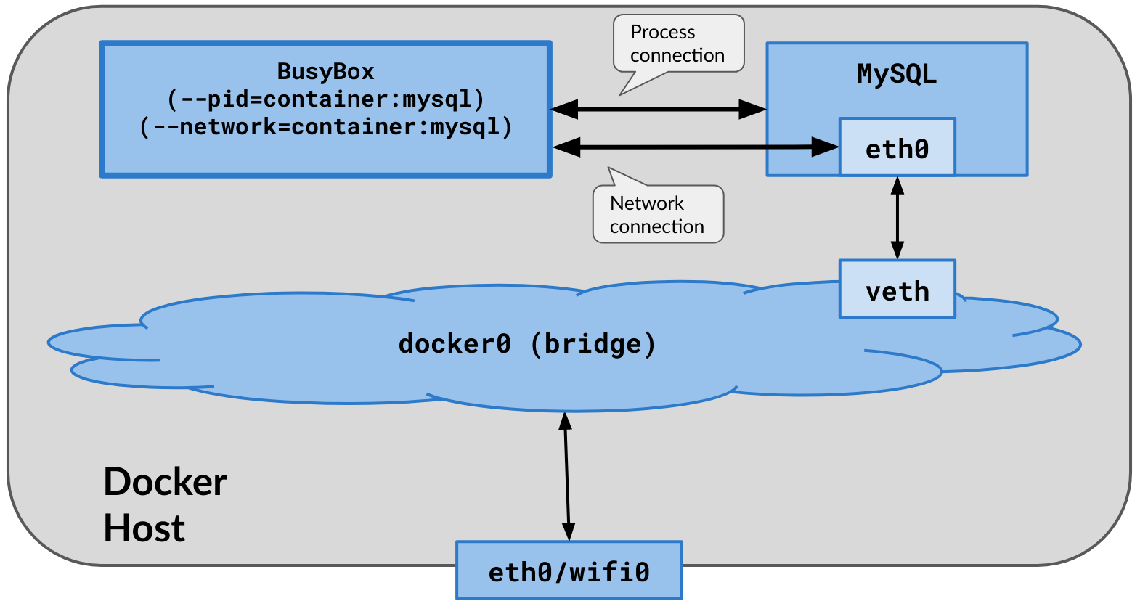

|  |
| --- |

Here is how it works:

dockerhost ~]$ docker run --name busybox \

--network container:mysql \

--pid container:mysql \

--rm -it busybox /bin/sh

/ # ip addr show

. . .

48: eth0@if47: <...UP,LOWER_UP,M-DOWN> mtu 1500 qdisc noqueue

link/ether 02:42:ac:11:00:02 brd ff:ff:ff:ff:ff:ff

inet 172.17.0.2/16 brd 172.17.255.255 scope global eth0

/ # ps aux

PID USER TIME COMMAND

1 999 0:33 mysqld

513 root 0:00 /bin/sh

518 root 0:00 ps aux

Notice the IP & MAC of mysql container, and processes from both containers - all visible in the busybox container!